AI Assistant Coding
Assignment-7.3
Name: V. Sai Anand
Roll No:2303a51310
Batch:05
Task 1: Fixing Syntax Errors
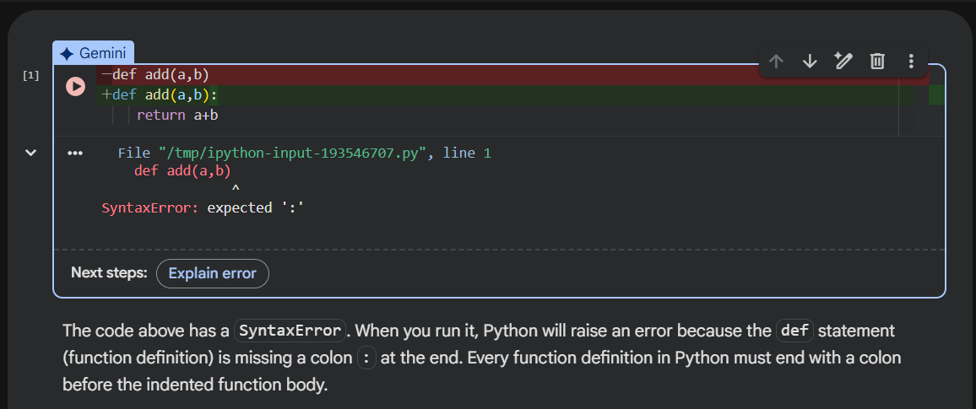
Code:
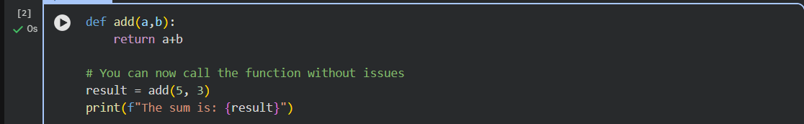
Output:
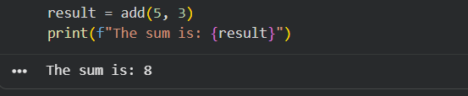
Code Explanation:
Colon (:) is mandatory at the end of function definitions, loops, and conditionals in Python.
- It signals the start of a block of code that must be indented.
- Forgetting it leads to a SyntaxError.
Task 2: Debugging Logic Errors in Loops
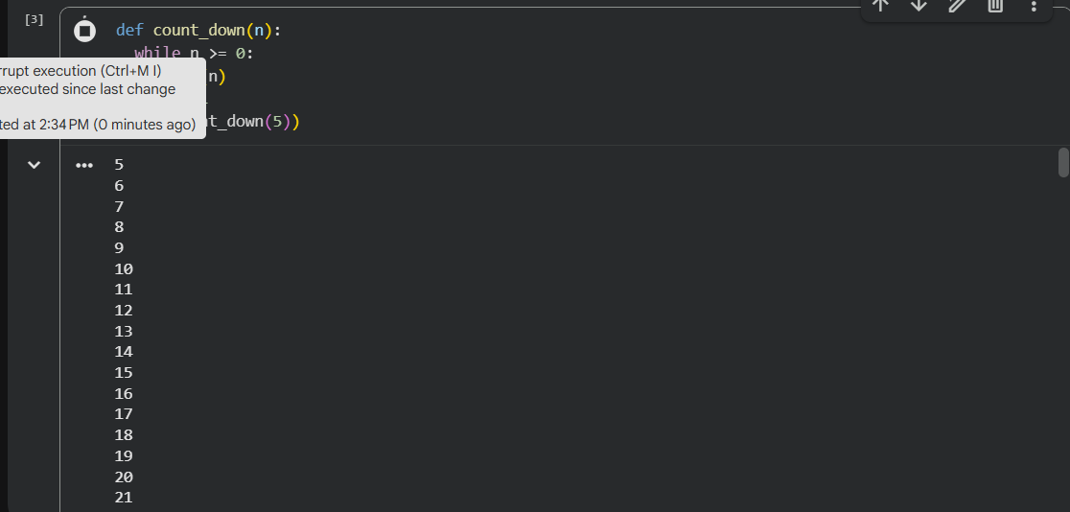
Code:
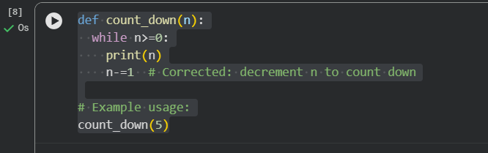
Output:
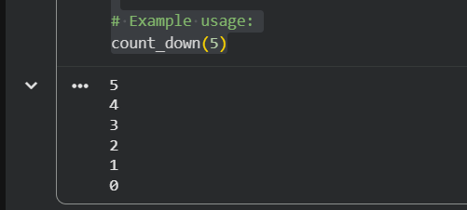
Code Explanation:
The original count_down function had a couple of logical issues:
- Infinite Loop: Inside the while n>=0: loop, n was incremented (n+=1), meaning n would never become less than 0, resulting in an infinite loop.
- Stack Overflow: The function recursively called count_down(5) within the loop, which would quickly lead to a stack overflow error.
Task 3: Handling Runtime Errors (Division by Zero)
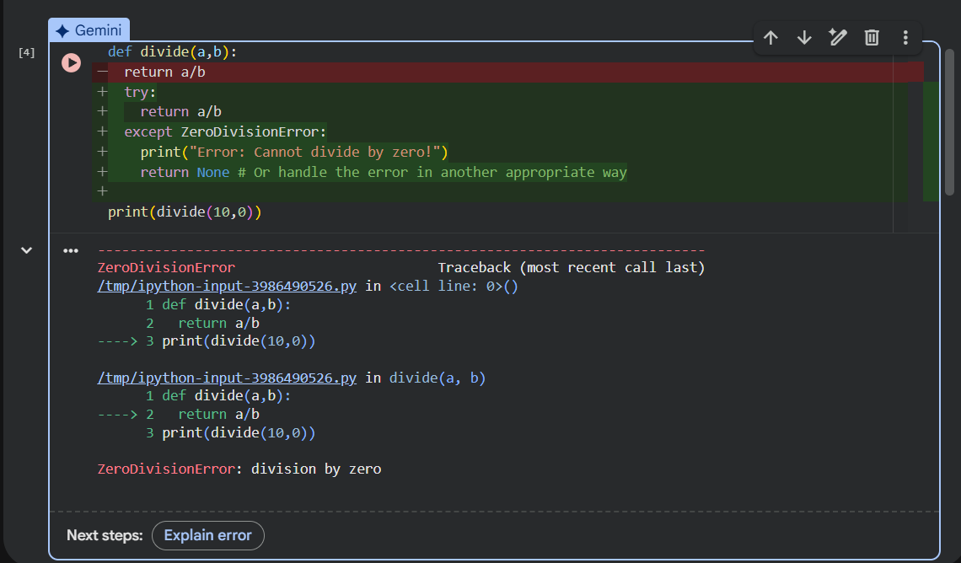
Code:
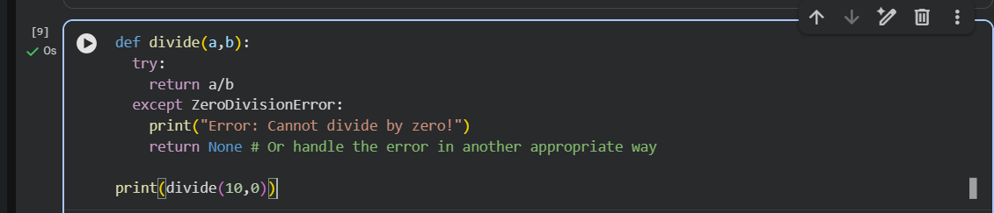
Output:


Code Explanation:
You're trying to divide by zero, which will cause a runtime error. I've updated the divide function to use a try-except block to catch the ZeroDivisionError and print an informative message instead of crashing. This makes your code more robust.
The divide function in cell mKyXoLbmPsgy executed as expected. Since you attempted to divide by zero, the try-except block caught the ZeroDivisionError, printed "Error: Cannot divide by zero!", and then returned None, which is also printed to the console.
Task 4: Debugging Class Definition Errors
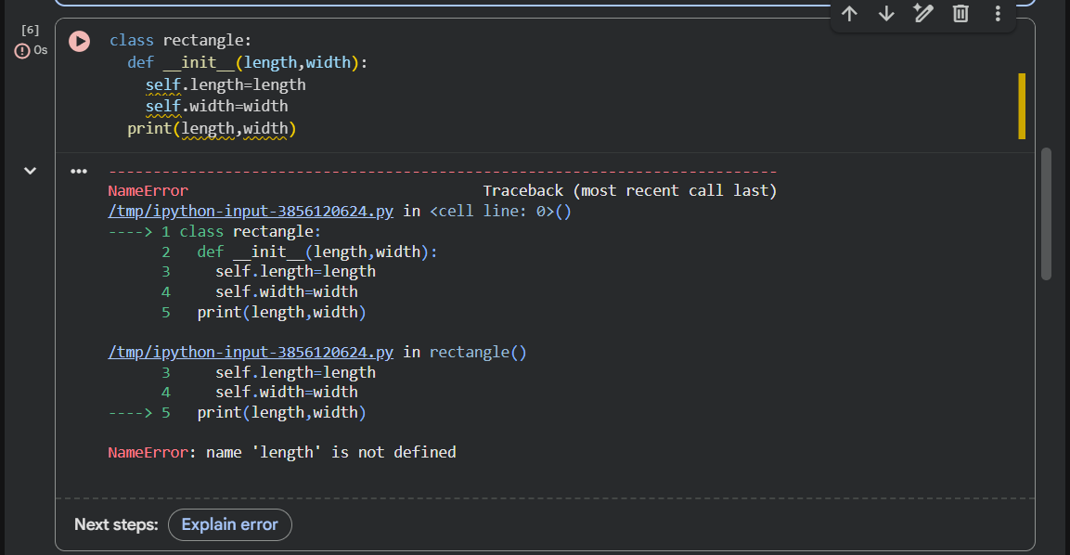
Code:
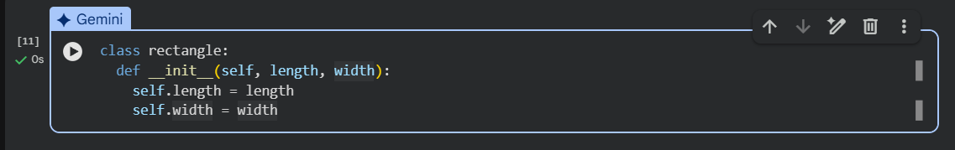
Code explanation:
Encountered a Syntax Error in your rectangle class definition. There are two main issues:
- Missing Colon: The __init__ method definition def __init__(length, width) is missing a colon (:) at the very end. All function and method definitions in Python require a colon.
- Missing self Parameter: In Python class methods, the first parameter must always be self. This refers to the instance of the object being created. You need to include self in the __init__ signature.

Task 5: Resolving Index Errors in Lists
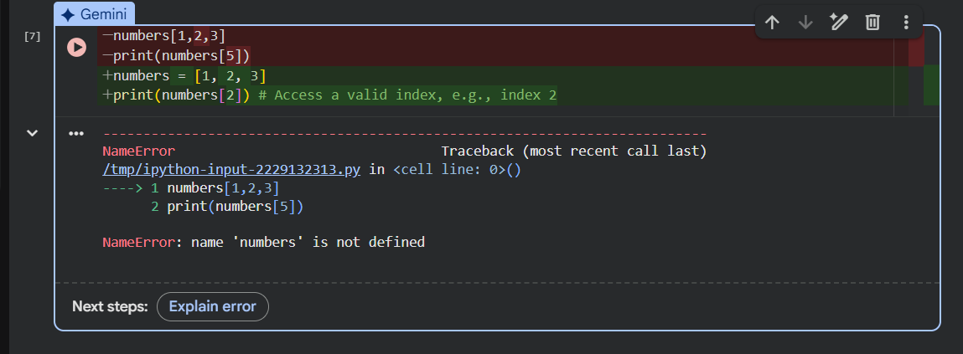
Code:
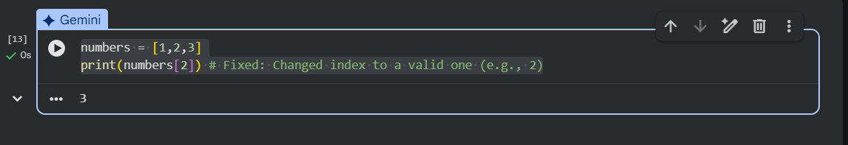
Code explanation:
The error you're seeing is an Index Error: list index out of range. This happens because your list numbers has only 3 elements (at indices 0, 1, and 2), but you're trying to access the element at index 5. To fix this, you need to use an index that is within the valid range of 0 to 2.

